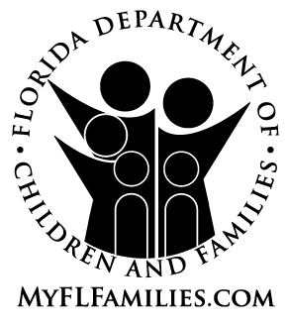 | Florida Department of Children and Families (DCF)  Interstate Compact on the Placement of Children (ICPC)  FINANCIAL – MEDICAL PLAN | 
Complete one form for each child. Complete one additional form for the same child for each separate resource being studied.
DCF District/Region | County | Date

Name of Child | Name of Resource | State

FINANCIAL PLAN (check only one)
Description of how the child’s shelter, food, clothing and related maintenance needs will be met in the receiving state.
DCF district/region will provide foster care payments at the receiving state foster care rate once the placement resource is licensed or certified as a foster parent by the receiving state.
The relative resource will apply for a TANF Child-Only Grant in the receiving state on behalf of the child.
(NOTE: TANF Child-Only Grants are not available in all states. Check with your district/region ICPC Specialist.)
The placement resource has agreed in writing to meet the financial needs of the child. Copy of the written and signed agreement must be attached.
This is a placement with a parent. The parent is financially responsible for the child.
Child is SSI-eligible. Resource will be made payee for benefits.
Adoption subsidy is planned and the amount will be determined prior to the date of placement.

MEDICAL PLAN (check only one)
Description of how the child’s medical coverage needs will be met in the receiving state.
The child is Title IV-E eligible. Copy of the Title IV-E eligibility document certified by the DCF district/region Revenue Maximization Unit must be attached (see CFOP 175-71,Chapter 3, paragraph 3-1). The receiving state will arrange for Medicaid coverage based on the Title IV-E eligibility.
The child will be eligible for Medicaid in the receiving state under the TANF Child-Only Grant.
The child is not Title IV-E eligible. The DCF district/region is financially responsible and will provide reimbursement for the child’s medical expenditures or make other arrangements as explained in the attached memo.
Child is Medicaid eligible as a recipient of SSI.
The placement resource has agreed in writing to provide for and meet the medical needs of the child. Copy of the written and signed agreement must be attached.
This is a placement with a parent. The parent is financially responsible for meeting the medical needs of the child.

When a child is placed in another state, the DCF district/region remains ultimately responsible for the financial and medical needs of the child and must retain jurisdiction over the child as required by Article V(a) of Section 409.401, F.S. In the event of a placement disruption or other reason to return the child to Florida, the DCF district/region may need to escort the returning child and must pay the associated transportation cost. This financial/medical plan will remain in effect during the period of the child’s placement in the receiving state.

Counselor’s  Signature:  Counselor’s  Name (PRINT):  Phone Number (including area code):  (Do NOT use SunCom numbers.) |  | Supervisor’s  Signature:  Supervisor’s  Name (PRINT):  E-Mail:
Attachments: Yes No
CF 791, PDF 10/2005

